**Debugging Interlude 1**

**Python Reading (22 total pts)**

Read the entire Debugging Interlude 1 chapter.

**Watch**

Watch: [Origins of “Bug”](https://www.youtube.com/watch?v=lQS0hDqpVLE)

**Checking Your Reading**

**Directions: Provide an answer for each question directly after the question on the copy of this document that you saved to your drive – please save it with the same name I have given it. When appropriate, you need to answer in complete sentences.**

1. Why is an error in a computer program called a bug? (2 pts)
   1. An error in a computer program is called a bug because a lady found a moth in her computer.
2. 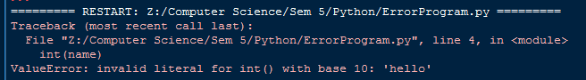Today's reading mentions that more than 90% of Python error messages fall into four categories:*ParseError*, *TypeError*, *NameError* and *ValueError*. Demonstrate each type of error in the Python environment. Copy and paste a screenshot of the output showing each error to this document. (5 pts each)

